Application for (Skills for Work course):

Personal Details
Surname: | Forename:
Name known: | Title:
Address: | Postcode:
Contact telephone numbers:
Landline: | Mobile:
Email address: | Date of birth:
If we need to, the best way to contact you is by:
Alternative email address:
Current school:
Area of permanent residence:

Tell us about your motivation to study this course
Why do you think you will succeed in this course?
Tell us about any relevant experience outside of any current/recent studies

Health
Do you have a medical/physical/other condition that may require additional support while on the programme?

Please select all that apply

I have a specific learning difficulty/difference such as dyslexia, dyspraxia, ADHA or dyscalculia
I have specific social/communication needs such as Asperger’s syndrome/other autistic spectrum disorder
I have a long standing illness or health condition such as cancer, HIV, diabetes, chronic heart disease or epilepsy
I have a mental health condition, such as an anxiety disorder, depression, mood disorder or schizophrenia
I have specific physical needs or mobility issues such as difficulty using arms or using a wheelchair or crutches
I am D/deaf or hard of hearing
I am blind or have a serious visual impairment uncorrected by glasses
I have a learning disability such as Down's Syndrome
I have a full or partial loss of voice
I have a disability or medical condition that is not listed above
I carry medicines which are time critical in their application (eg Epi-pen)
I have personal care support

Additional details
Are you a student who has a parent or carer who served or is serving in the regular or reservist British Armed Forces at any point during the first 25 years of your life?
Are you care experienced e.g. have you spent time in foster care, residential care, or have been cared for as a child by someone outside your immediate family?
Do you have unpaid caring responsibilities for a family member or friend who is ill, frail, disabled or has mental health or addiction problems?
Have you taken part in any formal activities/courses in preparation for Higher or Further Education?
What was the most important source of information in your decision to apply? | 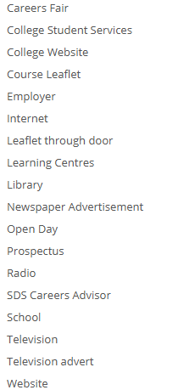

Declaration
I confirm that to the best of my knowledge, the information I have given on this form is correct
Enter full name

